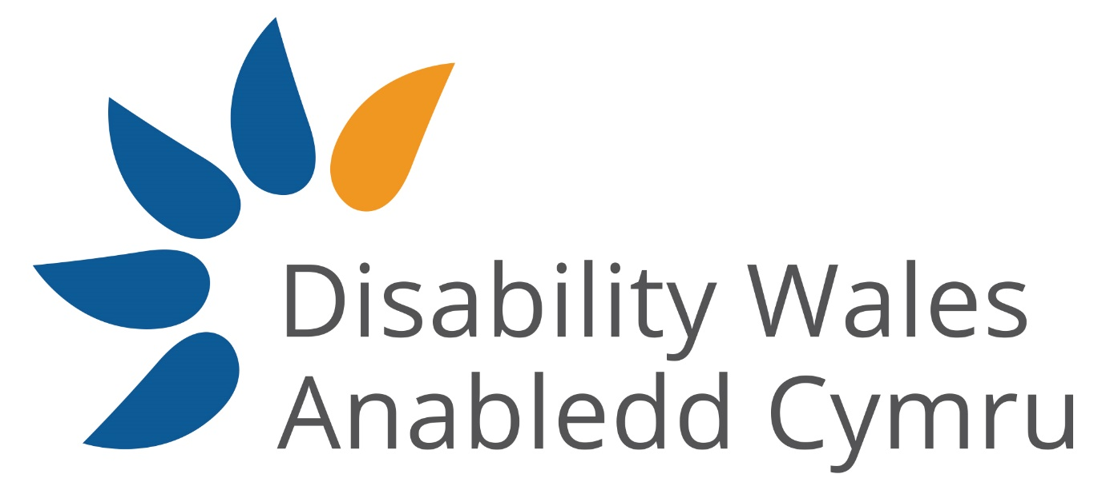

The Social Model of Disability
Tool Kit

Disability Wales is the national association of Disabled People’s Organisations striving to achieve rights and equality for all disabled people.
Disability Wales promotes the adoption and implementation of the Social Model of Disability, which identifies that it is environmental, organisational, and attitudinal barriers that disable people and prevent their full participation in society, not their medical conditions or impairments.
Visit our website to learn more about Disability Wales, the work we do and how you can become a member.
www.disabilitywales.org

Contents
The Medical Model of Disability 5
Language of the medical model 5
The Social Model of Disability 6
Barriers in a disabling world 7
Environmental 7
Attitudinal 7
Organisational 8
The importance of language 9
Use Identity First Language 9
Labels and collective terms 10
Social Model Language 10
Imagery 11
Employment Barriers 13
Attitudinal 13
Reducing Employment Barriers 14
Environmental Barriers 14
Information and Communication Barriers 16
Steps to reduce barriers in the workplace 17
New Staff Check List 18
Communication Support 20

Introduction
The social model of disability was developed by disabled people as an alternative to the medical model which was the main model used.
This toolkit has been developed to explain the social model and gives insight into how we can all use the social model in not only our daily lives but also how organisations can implement it.
This toolkit will go through the different ways disability is viewed by looking at the two main models used, the differences between them and why disabled people use this model.

Models of Disability

The Medical Model of Disability

The Medical Model of Disability regards ‘disability’ as a problem and/ or responsibility of the individual. It looks at the impairment, health conditions or neurodivergence as something that needs to be cured, treated, or made well and ‘normal’. It looks from the perspective of assuming disabled people ‘can’t’ do things.

The emphasis is placed on the person ability to do the same thing as others and the effort that is needed to get them to be as ‘normal’ as possible. It reinforces the negative message disabled people internalise that they are ‘less than’ or ‘not normal’, and as a result believe themselves to be so. This internalised negative message can lead some disabled people to be less likely to challenge the oppression, social exclusion, and discrimination they face.

Language of the medical model

Language is a powerful tool that allows people to gain understanding and insight into how disabled people are viewed by others. Words have the power to have a positive or negative impact on the way individuals view themselves and this is particularly emphasised for disabled people.

The Medical Model uses language such as pity, confined, suffers from and afflicted with, words that describe the disabled person and their impairment or health condition as a symptom of the medical model.

The medical model reinforces negative language that implies disabled people are ‘Victims of’, ‘confined and/ or bound by’ and ‘dependant’ because of their impairments, health conditions or neurodivergence. It portrays disabled people as victims. In contrast the social model uses language which is empowering, promotes independent living and aims to accurately describe the lived experiences of disabled people.

The Social Model of Disability

The social model began because disabled people began to speak up and say they weren’t happy with the ways in which they were treated, how little control they had in their lives and society’s attitude forwards disabled people. While the establishment of the Welfare State in Britain in the 1940s contained initiatives aimed at disabled people to improve their lives, the lack of progress towards social inclusion was being felt by disabled people by the 1970s. Disabled people began to form groups and conduct increasing campaigns. Disabled people undertook several battles at this time, including fights against forcible institution, segregation in ‘special needs’ services, higher rates of poverty and unemployment as well as restrictions on leisure and social relationships compared to non- disabled people.

The Social Model of Disability by comparison to the medical model does not recognise the disabled persons impairment, health condition or neurodivergence as a barrier. It turns the Medical Model approach on its head by saying its society’s environmental, attitudinal, and organisational barriers that are the reason a person experiences exclusion and discrimination.

The Social Model was created by disabled people from their own lived experiences, which is why it sees an individual’s impairment, health condition or neurodivergence as a characteristic of human differences to be valued on its own terms.

This model views disability as a social construct which is imposed on people through the way society is built and organised and rejects the medical model.

The social model identifies several different barriers which disabled people face (please see next page)

This way of viewing disabled people’s experiences is designed to promote social change through equality and human rights. The Social Model uses more positive language such as independence, human rights, equality, equity and opportunity. All of this empowers disabled people to stand up and challenge the discrimination and exclusion they face within society.

The social model does not deny the importance of impairment, appropriate medical interventions or, indeed discussions of these experiences. The social model is about disabled people receiving all information in accessible formats and ensuring they fully understand the possible benefits and side effects of all treatments so they can make informed choices.

Barriers in a disabling world

Disabling barriers exist in all areas of life for an individual with an impairment, health condition or neurodivergence. It is these barriers which are disabling, not an individual’s neurodivergence, health condition or impairment.

Environmental
- Large gaps or steep curbs
- Lack of dropped curbs
- The use of steps without other forms of access
- Broken or poorly maintained lifts
- Lifts that cannot be used without assistance
- Lack of accessible or changing places toilets
- Lack of Blue Badge Parking
- Long distances without seating
- Lack of suitable public transport
- Fluorescent lighting
- Lack of space for wheelchair users
- Inaccessible communications and images
- Inaccessible shop counters

Attitudinal
- Disabled people are childlike, stupid, not able to make decisions
- Needs to be looked after or pitied
- Is not capable or employable
- Less productive
- Not worth the effort or investment
- Must want a ‘fix’ or a ‘cure’
- Must be unhappy
- Disabled people with non- visible impairments treated with hostility as they ‘don’t look disabled’
- Dangerous or aggressive
- Unconscious negative bias
- Discrimination
- Stereotypes
- Negative media

Organisational
- Policies that use medical model terms and language
- Inaccessible practises and procedures
- Lack of flexible working options
- BSL – info at different times
- Awareness across organisations that all policies/ procedures/
- Accessible formats ready at same time as standard

The importance of language
Language is a powerful tool that allows people to gain understanding and insight into how disabled people are viewed by others. Words have the power to have a positive or negative impact on the way an individual views themselves and this is particularly emphasised for disabled people.

Impairment is the word used in the social model for an individual’s physical, sensory, neurodivergence, congenital condition or difference. Whereas a disability is the social consequence of having an impairment in a disabling society. People with health conditions, impairments or neurodivergence are disabled by society, this makes disability a social construct that can be changed and removed. The term ‘disabled person’ is a term people with impairments, health conditions or who are neurodivergent, use to emphasise that they are disabled by society because of exclusion and discrimination they face.

The medical model reinforces negative language that implies disabled people are “confined and/ or bound by” “victims of” and “dependant” because of their impairments, health conditions or neurodivergence. Whereas the Social Model ensures it uses language that is empowering, promotes independent living and aims to accurately describe disabled people’s lived experiences.

Everyone has the right to choose the language used to describe them and not everyone will agree on everything. There is however some basic guidance to language and terminology when it comes to the Social Model.

Use Identity First Language - In many situations you’ll often hear person first language being used, such as ‘person with a ‘disability’. There’s a misrepresentation here in that this is the best approach as these places the emphasis on the individual, by putting the person first rather than focusing on their impairment, health condition, or neurodivergence. However, for many this isn’t the language they would choose. Individuals will more commonly use identity first language, such as ‘disabled person’, as it highlights the barriers they face within society. This follows the Social Model understanding of disability. Many people feel that their impairment, health condition or neurodivergence is part of their identity and is why they choose identity first. Therefore, when using the Social Model, it’s important to remember that the respectful language to use is identity first language.

Using social model language can prove problematic when finding the balance between adopting and using terminology, whilst also respecting the language individuals or communities choose to use. For example, people with learning difficulties use the term Learning Disabilities and is used by the community and self-advocacy groups choose to use. This is not a social model term, which would be Person with learning difficulties, but there has yet to be an alternative agreed on which the community themselves are happy with and is accepted as part of the social model of disability.

Labels and collective terms - When we use labels and collective terms, for example the word ‘disabled’, it is a description of an individual’s experience. Therefore, terms such as “disabled people” are preferable, rather than “the disabled.” However, many D/deaf people whose first language is BSL consider themselves part of the ‘Deaf Community’ – they may consider themselves as Deaf, with a capital D, to emphasise their Deaf identity.

Don’t automatically refer to ‘disabled people’ in all communications. Many people who receive disability benefits and services do not identity with this term. Consider using ‘people with health conditions or impairments’ if it seems more appropriate. We should be confident in the language and phrases we use every day.

Social Model Language
Words to use | Words to avoid
Disabled Person | Person with a disability
Non- visible impairment/ health condition | Invisible Disability
Wheelchair User | Wheelchair bound
Non-disabled | Able- Bodied
Vision Impaired | Blind
Hearing impaired/ Deaf/ Hard of hearing | Deaf and dumb
People with additional needs | People with special needs
Person with learning difficulties | Person with learning disabilities
Health condition | Disability
Impairment | Disability
Mental health condition | Mental health illness/ Mental illness
Personal Assistant | Carer

The language of the social model is constantly evolving as it comes to how disabled people feel. An example of this is the change from ‘hidden’ impairment or health condition. Following discussions it was decided that ‘hidden’ impairment would not be used anymore as disabled people are not hiding their impairments, health conditions or neurodivergence, but rather the condition or impairment is non- visible.
Not everyone will identify with chosen language, including social model language. People have the right to use any language to identify themselves. However, the words we use to describe different groups of people have an impact on the way people are seen by others and can hurt people’s feelings.
Most disabled people are comfortable with words used to describe daily living. Wheelchair users still ‘go for walks’ and people with vision impairments may be very pleased, or not, to ‘see you’. Common phrases which associate impairments with negative things should be avoided, such as ‘turn a blind eye’ or ‘crippled by debt’ and ‘deaf to our pleas’.
Disabled people enjoy jokes the same as non- disabled people do. However, jokes which focus on a person’s health condition, impairment or neurodivergence should be avoided, as should using derogatory and out-dated language.

Imagery

As individuals you hope to see yourselves represented in the world you live in whether you are visibly disabled or not, this is what allows us to feel equal and a part of the community, what enables us to feel part of society and how we connect with people. When you do not see yourselves represented you can feel that you are not considered equal to others, or not considered at all. For many disabled people this is often the case. Media advertisements, television shows; even marketing campaigns for employment opportunities very rarely have diverse representation particularly when it comes to disabled people. This can be problematic as this may cause other members of society to build a prejudiced attitude that can lead to discrimination and hate crime.

When adopting the Social Model, use images that reflect the diversity in our communities, challenge stereotypes and help break down barriers. Images selected should represent disabled people as active citizens, exercising choice and control including interacting with people in the workplace, school or social setting. This will allow disabled people to feel more represented, not feeling tokenistic and part of the community. Try not to only use images of wheelchairs to represent disabled people and instead include people with various impairments or equipment.

Include disabled people in images/ stories that aren’t specifically disability related to show that disabled people are more than their health conditions or impairments. Including disabled people in more images helps to show inclusion and the organisation commitment to accessibility.

Engaging with Disabled People
When engaging with disabled people, whether face to face, over the telephone or virtual meetings, it is important to remember a few things.
Disabled people are a varied bunch! Never assume what a disabled person can or cannot do. Talk to them, ask about barriers they are facing or expect to face, and work together to reduce these barriers. Disabled people usually know best what equipment or adjustments they require to fully participate so it’s important to keep the disabled individual in all conversations that concern their health condition, impairment or neurodivergence so they can make the decisions.
It is important to not assume a disabled person needs help. Often it is assumed help is needed when it may not be. It can also be scary for some disabled people when, for example, someone handles their wheelchair, meaning the disabled person loses the control over their wheelchair. Ask if someone would like assistance before touching their wheelchair or other equipment.
Always speak directly to the disabled person, even if they have a personal assistant or carer with them.

Employment Barriers
In Wales, there is a 31% employment gap for disabled people. Despite government programmers to get disabled people intro work, the figure has remained similar for many years. Working isn’t an option for all disabled people, but many disabled people want meaningful, paid work. Disabled people face many barriers around employment. From the recruitment process and interviews to barriers within the workplace, disabled people face barriers throughout. These barriers can include all aspects of a workplace, far beyond purely physical environmental barriers. Under the social model they can be split into categories of barrier types.
The barriers disabled people face to, and in employment are numerous. These disabling barriers include;

Attitudinal
- A misconception that disabled applicants will not be as good as non-disabled applicant.
- Fear that employing disabled staff will be expensive.
- Lack of confidence around employing and managing disabled people
- Employers believing the myths about disabled people employment, that disabled people are;
  - Less productive
  - More likely to take time off sick
Years of hearing medical model language and treatment, can mean disabled people also face barriers to employment including
  - fear of rejection on declaration of health condition/ impairment
  - Fear of not receiving required adjustments and support
  - Lack of confidence
  - Being discriminated against and not feeling confident to challenge
  - Insufficient skills to sell themselves

Reducing Employment Barriers

Numerous studies have shown disabled people tend to take less time off work sick than non- disabled people. They also tend to stay in positions longer and show good commitment to organisations who provide a supportive and accessible workspace.
Reducing attitudinal barriers can be done in the workplace by;
- Undertaking Disability Equality training for all staff to increase knowledge and understanding. This training will help to challenge some myths that persist.
- Ensuring social model language is used in all organisation materials including recruitment and policies.
  - Say “Do you identify as disabled?”, not “Do you have a disability?”
  - Engage with charities and organisations who can share lived experience and knowledge.

Environmental Barriers
Environmental barriers are frequently the first barriers non- disabled people think of, such as inaccessible access caused by a lack of step free access. But environmental barriers go a lot further than steps. They also include offices/ cafes with a lack of spacing between tables/ desks which creates barriers for disabled people. Some of the environmental barriers disabled people face in the workplace, these include;
- Inaccessible location and/ or building
  - Lack of lift access to higher floors
- Lack of accessible transport
  - Lack of suitable public transport
- No provision for disabled parking spaces
- Job requirements that aren’t justifiable
  - Can you justify requiring a degree for the role or could other evidence be supplied?
  - Avoid adding a requirement for a driving license if the job can be completed using other transport or is office based
- Inaccessible or inappropriate work trials or psychometric tests
- Space not wheelchair accessible
  - Desks too close to each other
  - Boxes/ storage reducing available space
- Fluorescent lighting
- Fire regulations
  - Ensuring everyone fully understands polices and procedures around fire safety

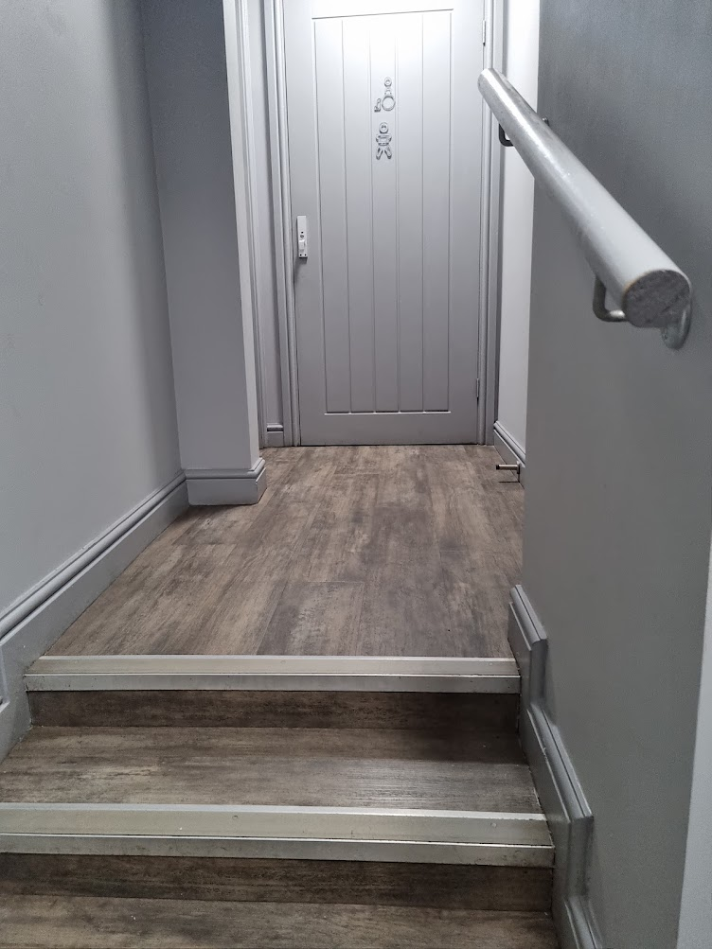
Figure 1 steps leading to a toilet marked disabled

Figure 1 shows a toilet marked as accessible, but up steps. This shows that the toilet was tokenistic with no work to ensure it was accessible for disabled people to use.
Environmental barriers can be reduced by working with disabled people using lived experiences to provide feedback on building plans. The barriers faced by disabled people are varied and is likely to differ between disabled individuals. By involving disabled people at planning stage they can provide feedback on accessibility from their lived experiences.

Information and Communication Barriers
Providing information and communicating in an accessible format is a fundamental area of accessibility. Without accessible formats, disabled people can be left without access to information, this could be access to information about a health condition or other personal subjects which a disabled person may not wish to share with family/ friends and would like to access the information alone.
Barriers to information and communication can include;
- Job information not available in accessible formats, such as only available in PDF
- Inaccessible application process (online forms only)
- No contact details for questions
- No available hearing loops
- Information not available in accessible format
- Videos without captioning or BSL

Steps to reduce barriers in the workplace
There are steps all organisations and workplaces can do to improve accessibility.
When writing job descriptions ensure only necessary duties and responsibilities are listed
  - For example, avoid adding ‘must have full UK driving licence’ if the job is done from an office/ home
  - Consider what qualifications are truly required, a personal assistant is unlikely to need a degree, their personality and ethics are more important.
  - Avoid stating ‘must be fit and healthy’ as this can be unclear to disabled people who may consider themselves fit and well, as well as disabled. State the tasks of the role which may be physical to better represent if the role is suitable for disabled people
When recruiting ensure information is provided in accessible formats, avoid using PDFs instead use word documents for users of screen readers and offer different colour backgrounds. Consider if different application processes can be offered, such as video statements. Use clear fonts such as Calibri or Arial at least size 14, avoid using italics.
To begin in creating a fully accessible workspace start by providing Disability Equality Training to all staff and volunteers is a great way to reduce attitudinal barriers as it provides insight into a disabled people’s lived experiences. This training should be provided by disabled people to ensure lived experiences of disabling barriers.
Promote a positive culture towards employing disabled people through equal opportunities, imagery, terminology, and policies. Be mindful of the language you are using and always use language that’s empowering, promotes independence and represents disabled people’s lived experiences. Check language in policies, avoid using words like ‘suffering’, such as ‘do you suffer with/ from...?’. Instead use social model language and ask if someone identifies as disabled and if they have any access requirements.
Providing examples of adjustments can be helpful to show employees what adjustments exist and how they can be requested. Supply information on the Access to Work scheme, including how it can be applied for and what the fund can provide for, that employees may not be aware is available, such as personal assistants, note takers as well as equipment and software. Disabled people may not be aware of what support and/ or equipment is available.
Have a ‘Disability Ally’, ideally who is a disabled staff member, who can engage with new employees, explaining policies and providing information. Creating a disabled staff network can be beneficial and help disabled staff to feel represented.
Provide time to meet with disabled staff to talk about barriers they may be facing and discuss together how these can be overcome, whether through a reasonable adjustment or equipment/ software
Have regular catch ups with staff to ensure you’re aware if their condition or impairment changes and discuss with the employee what barriers they are facing, and any adjustments required. Consider how indicators of work performance is measured.
Consider conducting access surveys and individual workplace assessments for disabled staff so barriers can be identified and removed.

New Staff Check List
When hiring new staff members/ volunteers follow a checklist to ensure required adjustments are implemented and any barriers discussed. This should be used for all staff/ volunteers, those that consider themselves disabled or not as some non- disabled may still benefit from adjustments. A standard checklist is provided below.

- On job advertisements ask, “Do you consider yourself disabled?” or “Do you have any access requirements?”
- List the ways contact can be made and how BSL or a Personal Assistant can be requested.
- When offering interviews ask again if they have any access requirements, including an example of adjustments e.g. questions in advance, extended time for tasks
- Ask if they face any barriers / foresee any that may occur while doing work, discuss way in which the barrier can be removed or reduced
- Talk about what adjustments/ equipment/ software the disabled person will require, do not rely solely on the disabled person to be aware of all software or equipment which exists and if they would benefit
- Supply information on location, what transport is close and if there is parking
- Give information on any workplace disabled groups/ staff networks
- Set up regular catch-up meetings where barriers and adjustments can be discussed and solutions found
- Provide information on Access to Work

Within the office
- Is enough room between desks/ chairs for a wheelchair to access and turn?
- Consider current lighting levels/ lighting types, a disabled person with a sensory impairment or neurodivergent may have light sensitives and work better in natural lighting
- Is there desks at a suitable height or adjustable, for wheelchair users?
- Ensure the disabled or accessible toilet is free from stored items
- Check there no wires laying on the floor which may be a tripping hazard
- Provide notebooks/ paper in additional colours beyond white, yellow or purple are popular choices
- If the office is busy/ noisy provide a quiet space if possible, or headphones if no quiet space is available.
- If workers will be using certain software/ equipment in the workspace, set aside time to ensure the disabled worker is confident using it or if an adjustment or specialised training or training in a different format, is required.
- Check any lifts are in full working order
- Are the internal and external doors accessible for disabled people and useable for wheelchair users
- Fire safety points – visitors and staff – can feel uncomfortable asking – signage is very important
- How equipment/ belongings are kept to ensure space is clear
- Contacting relevant 3rd sector organisations

Communication Support
Communication support can include British Sign language interpreters, lip- speakers, deafblind interpreters and palantypist.
A palantypist provides speech to text which can be displayed as closed captions or an external link. They can be sourced through the Royal Ass
British Sign Language Interpreters
If you are expecting a user of BSL to attend an event or training session it is worth speaking to the individual to discover if they have a preferred interpreter.
Providers:
Royal Association for Deaf People - BSL interpreters -communicationservices@royaldeaf.org.uk
Welsh Council for Deaf People – BSL interpreters, Palantypists, Deafblind Interpreters
https://www.wcdeaf.org.uk/communication-service-providers
Communication support workers must have frequent comfort breaks, every 40 minutes. It is important to factor this in when planning events or meetings.

