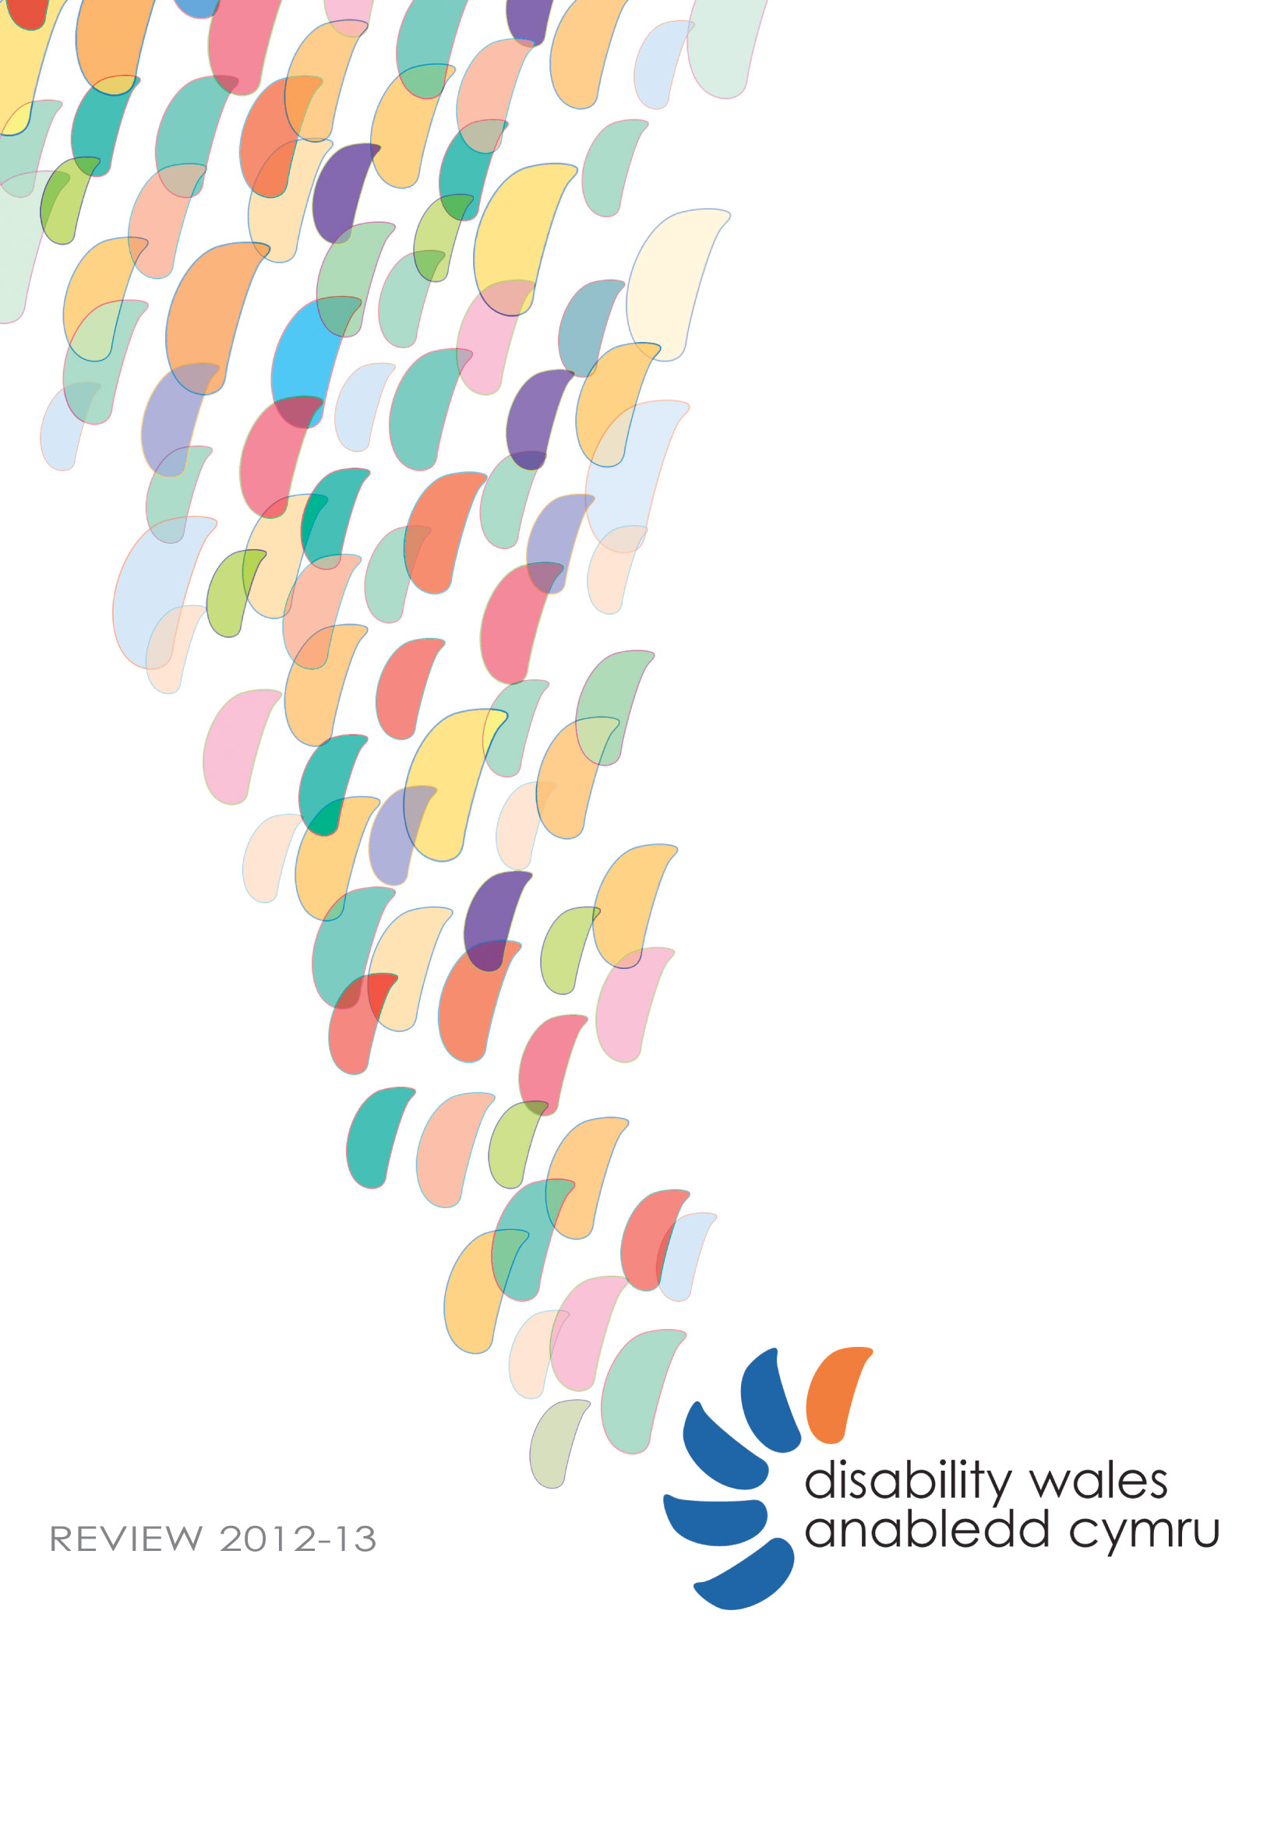
This document is available in Braille,
large print, audiotape and disk.

Disability Wales receives funding from the
Welsh Government

Published by Disability Wales 2013
Translation by Beuno Hughes
Designed by Andy Dark
Disability Wales is a registered charity, No. 517391
and a company limited by guarantee, No.1998621

Bridge House
3 Caerphilly Business Park,
Van Road,
Caerphilly
CF83 3GW
Telephone: 029 2088 7325
(Please use announcer for Minicom)
Fax: 029 2088 8702
Email: info@disabilitywales.org
Web: www.disabilitywales.org

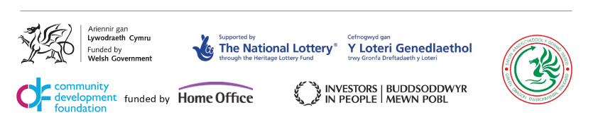

Mission
Disability Wales is the national association of Disabled People’s Organisations striving for the rights, equality and independence of all disabled people.

Strategic aims
To develop and support the work of organisations led by disabled people
To be an effective advocate for their views, priorities and interests of our members
To influence policy and decision makers at all levels
To develop and deliver services that benefit disabled people

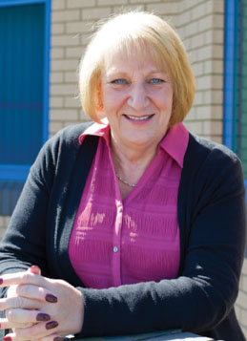

From the Chairperson

Once again it's that time, in my role as Chair of Disability Wales, to review our activities during the last financial year.

April continued our 40th Anniversary celebrations in earnest, with a showcase event being led by four members of Pembrokeshire Young Voices for Choices, and two support staff circumnavigating Wales by public transport, with the aim at stopping at 40 locations along the route.

The purpose of the trip, was to highlight cases of good practice, and areas in need of improvement, with regard to access to public transport, railway stations, coach stops and taxi services, along their route. The adventurers videoed their evidence; tweeted their experiences, and attracted considerable media coverage. Our thanks for support go to Arriva Trains, bus services, linking coach, taxi services and accommodation providers. The trip, which took place over four days of the Easter holidays, started at Haverfordwest Railway station, and finished with a reception and presentation by the young people, at Pembrokeshire County Hall at the end of their four days travel.

The other significant event linked to the Anniversary was the 70’s themed dinner and disco, on the eve of the AGM and Conference which took place in Wrexham in October 2012. This was our chance to celebrate what DW and the wider Disability Movement has achieved over the preceding 40 years. We may still have a way to go, but a lot has been achieved over that time. As an organisation, and across the voluntary sector in general, we are so busy fighting for our rights, that we do not always take time to recognise what we have actually achieved, this was an appropriate moment. The Anniversary, which was launched in the Senedd in January 2012, culminated in an event at the Pierhead Building, Cardiff Bay, on 3rd December, International Day of Disabled People, with the launch of the “Story at 40” video, the final part of the project supported by the Heritage Lottery Fund, where disabled people – all around the age of 40, and from all areas of Wales, recorded their experiences of living with an impairment throughout the 40 years of Disability Wales existence.

Moving on to more general matters in the work of Disability Wales, we have, like all other voluntary organisations, had to tighten our belts in terms of finance, with the reduction of monies available to financially support the organisation. We have had to consider ways of generating more income for ourselves and to this end held two joint Board and Staff Staff Business Development Days where some promising ideas emerged.

Work on the Framework for Action on Independent Living continues to underpin many of our activities, as does work around Welfare Reform and Hate Crime. There has been a very successful theatre project around Disability Hate Crime, this was so successful in its pilot runs in secondary schools in the Bridgend area that more funding was made available by the Welsh Government to perform it in other counties across Wales.

During the year we said goodbye to longstanding Director Judith Pennington as well as Lesley Keetley and thank them both for their contribution to DW.
Once again, I wish to thank all Directors, our Chief Executive, Rhian Davies, and the staff team for all their continuing hard work and support during very trying financial times, but also for making our Anniversary year so special.

Wendy Ashton Chairperson

Treasurer’s Report

Before I give my annual report I would like to thank Paula Reed our office manager who put in the hard work preparing the accounts. I would also like to that our auditors Bloomfield Alexander for their work and invaluable advice.

This Year
This is the first year of a three year funding agreement with the Welsh Government. The level of our core grant has been set at the same level as last year and will be held at that level throughout the three year run. This means facing an estimated cut in real terms of 2-4% year on year.

Despite this I can report an increase in our surplus this year to £24,151. This was only possible due to our income from provision of services increasing to £41,452.

For Disability Wales to continue the work program the Trustees and staff wish to carry out, while, at the same time our core grant decreases in real terms, our ability to earn income in the open market must increase.

Reserves Policy
The stated aim of the reserves policy is to allow for unforeseeable events. This could be anything from a failure of a critical piece of office equipment, to the sudden loss of all funding.

The aim is to hold six months operating costs, included in this, is the ability to meet all our obligations.

Our total unrestricted reserves at year end were £385,910; this includes the four ring fenced reserves for Redundancy (£72,119), legacies (£156,949), Campaigns (£9,650) and the Bursary scheme (£2,794).

The total reserve required to meet the policy is £255,073, with current reserves and taking all our obligations into account the reserves policy is fully met.

The Future

Short term
With the real terms cut in core funding, Disability Wales will need to secure alternative means of funding. The need to drive forward new business ideas cannot be overstated. The Trustees have embraced this new emphasis and with the appointment of a Business Development Manager, and our team of dedicated staff, I have every confidence that the organisation will rise to the challenge.

Mid to long term
With the continuation of slow to no growth in the economy as a whole, we can expect the squeeze on grant income to also continue. To grow the organisation the development of new business ideas and new partnerships will have to move ever onward, only the organisations that can adapt to the new, more austere funding regime can hope to survive. I have every confidence that Disability Wales will remain as long as the fight for equality continues.

Stephen Sweetman Treasurer

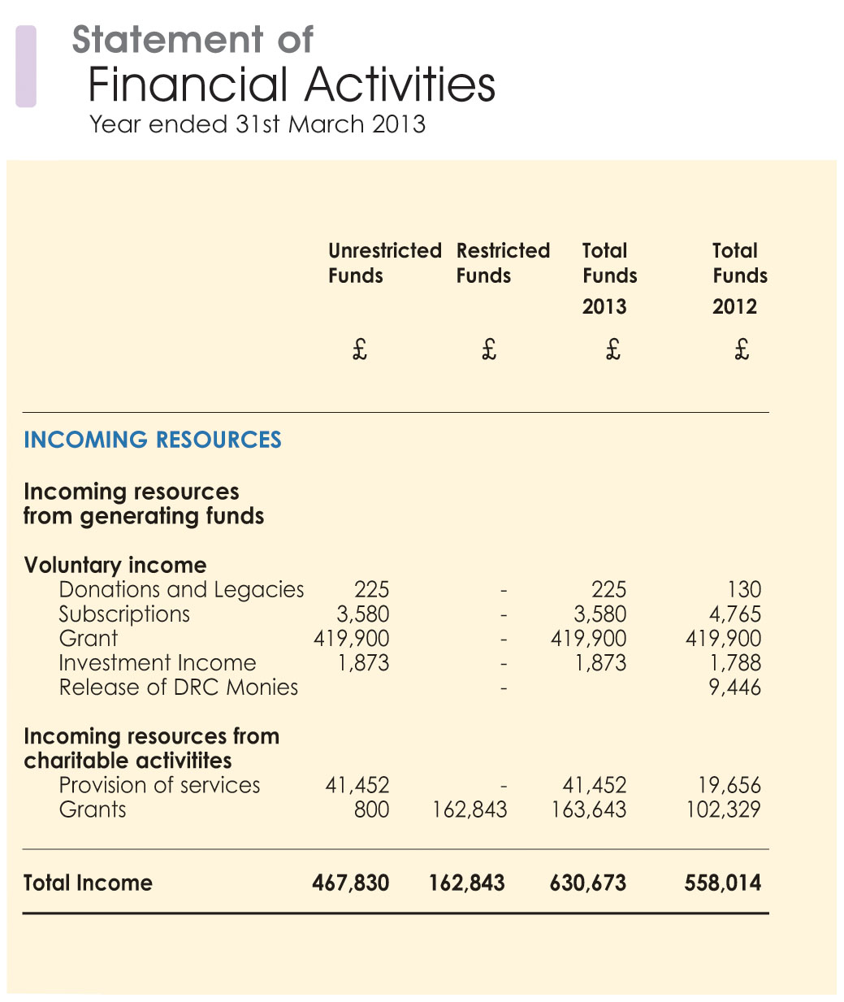

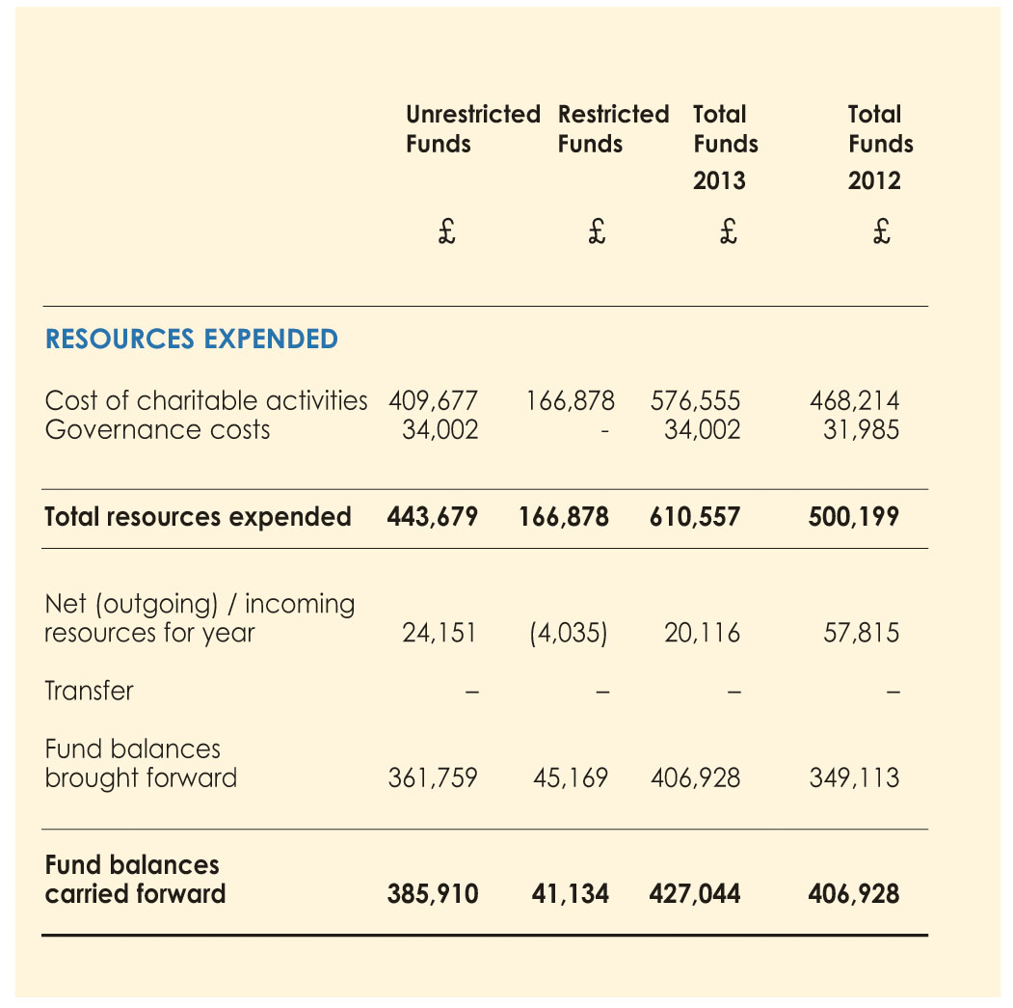

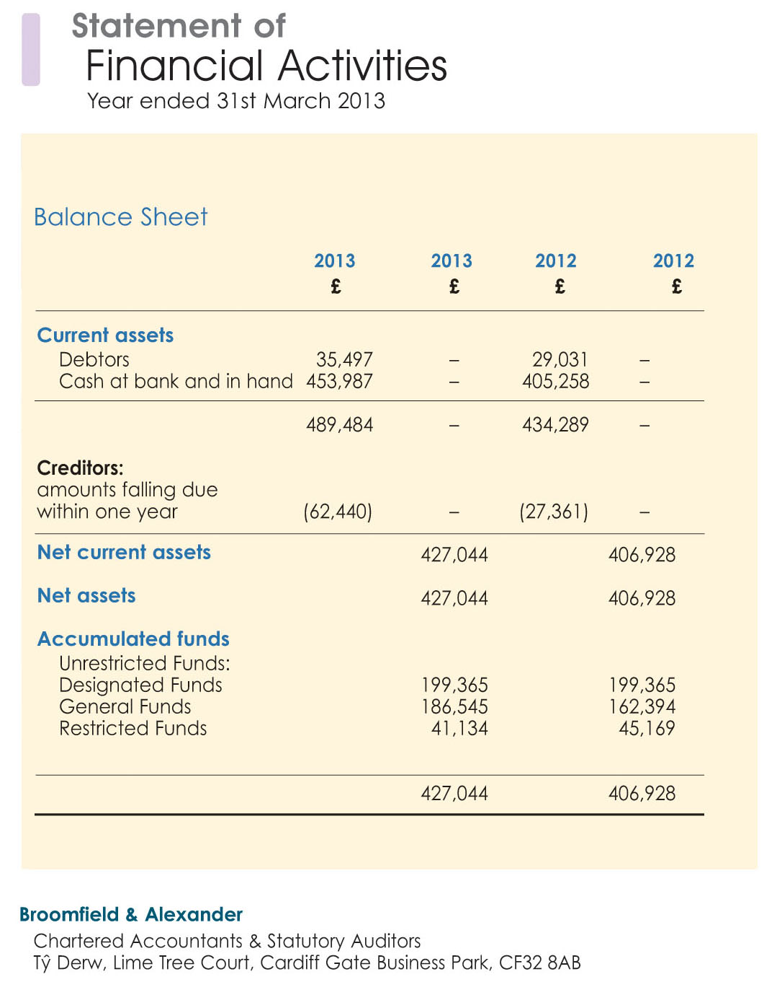

Board of Directors 2012/2013

Chairperson
Wendy Ashton

Treasurer
Stephen Sweetman

Board Members
Amanda Glover
Natasha Hirst
Lesley Keetley
Terry Mills
Nicholas Pearson
Judith Pennington (resigned 18 October 2012)
David Power
April Harper (resigned 12 july 2012)
Ivor Jones (appointed 18 October 2012, resigned 30 December 2012)

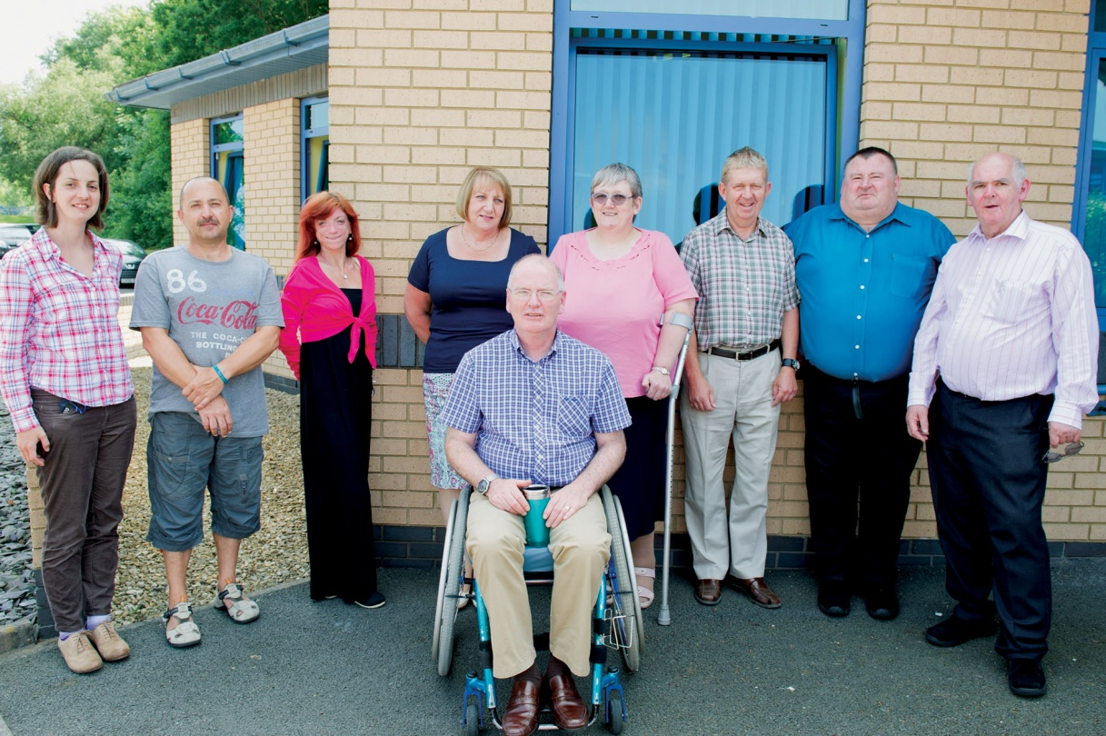

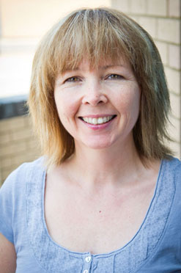

Introduction from the Chief Executive

“I would…..like to pay tribute to Disability Wales. Your petition for independent living provided the starting point for this work, and you have been a crucial partner in getting to this point.”
Jane Hutt AM, Minister for Finance and
Leader of the House

Disability Wales strives to achieve the rights, equality and independence of all disabled people and is delighted to report on the progress it is making towards this goal despite a very challenging social, political and economic environment.

As an organisation that campaigns and seeks to influence policy, measuring our impact is not straightforward. However in one area in particular DW’s contribution to influencing policy is significant namely the introduction of the Framework for Action on Independent Living, launched for consultation by Welsh Government during our 40th Anniversary year.

The Framework is underpinned by the Social Model of Disability and the principles enshrined in the UN Convention on the Rights of Person’s with Disability. Furthermore it is incorporated into Welsh Government’s Strategic Equality Plan and although in draft form several actions have already been undertaken including reviews of Accessible Housing Registers and Design and Access Statements respectively. These were prompted through the extensive engagement between officials, members and stakeholders which DW co-facilitated with WG during the development of the Framework and has been hailed by many as a model of co-production.

Given the cross-cutting nature of the Framework we anticipate that once implemented it will have a major impact over time on the lives of disabled people across Wales and their opportunity to live independently in the community.

In the meantime DW has delivered across its Work Programme including producing one film – The Story at 40, one Theatre Forum play – Real Human Being and three new publications: the Way to Go Planning Toolkit, Cap-in Hand and Know your Rights, Use your Rights, Live your Rights! We have run nine events across Wales attracting nearly 500 participants, with Real Human Being reaching well over a thousand young people as it toured schools and youth centres across Wales. Our Social Media pages on Facebook and Twitter also reach thousands of individuals and organisations.

To take forward our work on Digital Inclusion we created a new post of Digital Communications and Inclusion Officer and welcomed Tina Evans into the role, initially on a temporary contract but extended following a successful bid for Communities 2.0 funding. Due to a vacancy arising we also created the post of Business Development Manager to assist DW take forward our Funding Strategy and generate new sources of income. Chris Davies joined us in March and although has since moved on made a valuable contribution to this work.

I also thank our volunteer Kathryn Harris who was actively involved with a number of our projects during the year including Way to Go and Story at 40 and has now secured a job with the mental health charity Gofal.

The scope and range of DW’s work would not be possible without the dedication, commitment and enthusiasm of our staff team together with the guidance and wisdom of our Board of Directors. I am indebted to all for their support and continued optimism in a future where disabled people achieve full equality, rights and independence.

Rhian Davies Chief Executive

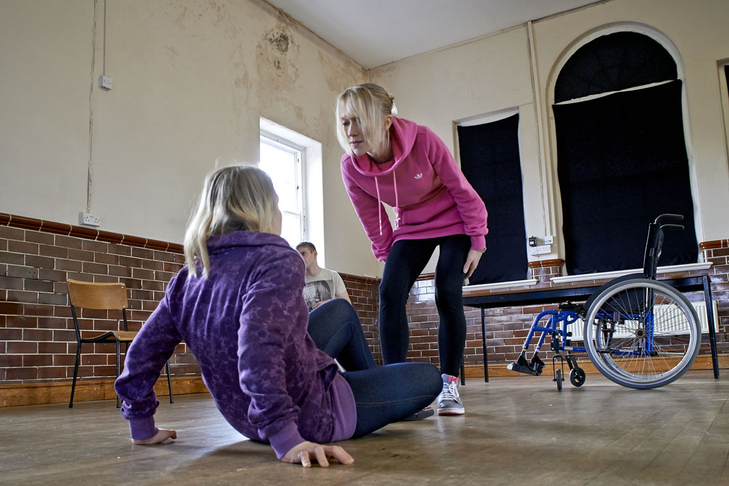

Impact Report 2012/2013

Objective 1:

To develop Disability Wales as a strong membership-led organisation

As an umbrella body DW is committed to developing the capacity of its membership through supporting the development of new groups of disabled people as well as providing information, training and resources to existing members.

Developing new Disabled People’s Organisations

Linked to the application to the BIG Lottery Community Voice programme, DW worked with disabled people in Pembrokeshire and Ceredigion to develop new organisations in each county.

Pembrokeshire: DW worked in partnership with Pembrokeshire Association of Voluntary Organisations (PAVO), Vision in Wales, Crossroads Care Mid and West Wales, and Theatr Fforwm Cymru to arrange an event open to disabled people and carers in the county. Attended by more than 40 individuals it was agreed unanimously to form a new disabled people’s organisation to be called Pembrokeshire Independent Living Action Group.

Ceredigion: working in partnership with Ceredigion Association of Voluntary Organisations (CAVO) and Disability Action Group Wales DW assisted with the planning and delivery of an event held in Aberystwyth. Attended by more than 80 participants and co-chaired by Council Leader Elen ap Gwyn and Chairperson of DAGW Tony Hawkins it provided a platform to launch the development of a new group: Ceredigion Disabled People Together.

DW looks forward to welcoming both new groups into full membership in the near future.

Supporting our members

DW provides a range of support to members through events, training, and the development of resources. These are aimed at keeping members informed, developing new skills, and enabling them to work effectively in their local area.

Know your Rights,
Use your Rights,
Live your Rights!

DW’s three year development programme is aimed at equipping members with knowledge and information about disabled people’s rights under the UNCRPD, the Equality Act (2010) and the Wales Specific Public Sector Duties and how these can be used to promote equality, and eliminate discrimination and harassment in their community. The programme is designed to support and empower disabled people in the face of substantial cuts in benefits and services. This includes influencing the design and delivery of public services locally as well as challenge decisions which are not in line with equality laws.

DW’s programme ‘Know your Rights, Use your Rights, Live your Rights’ will encompass both policy and membership work in arranging events and seminars and in producing an accompanying resource pack.

DW launched the programme at its Annual Seminar held in Wrexham. Attended by 65 members and stakeholders, expert speakers included Lord Dafydd Wigley on ‘Parliamentary Campaigning’, Debbie Jolly from Disabled People Against Cuts on disability rights, and Diane Mulligan OBE on the UN Convention on the Rights of Persons with Disabilities (UNCRPD). The event was chaired by Matthew Richards from BBC Wales.

The event was well received, with members reporting an increase in their knowledge and understanding of equality issues:
“Learnt a lot about how individuals can contribute to evidence
on UNCRPD. Another excellent DW event – thanks to all staff
for their hard work”.

Regional Events

Digital Lives

A one day event held in Llanelli in partnership with Carmarthenshire Disability Coalition for Action on the theme of digital inclusion, using ‘Sarah’s Story’ from the Story at 40 project. A select group of 11 participants received presentations from Nigel Hayton (LC Disability), Marcus Griffiths (Computer Recyclers) and Karlis Ozolins (Wales Co-operative Centre Digital Inclusion Officer)

Way to Go:
Planning for Inclusive Access

“It has raised my awareness of what I can do in my job to fulfil the requirement of the Equality Act & the needs of other people.”

DW delivered the final year of its successful three year project ‘Way to Go’ funded by the Welsh Government Advancing Equality Fund, bringing together the three elements of the initiative aimed at supporting disability groups and planning officers around Wales. It included the fourth regional development and training programme, delivery of the Mediation pilots and production of the Planning Toolkit.

Training and Development Programme

“[I learned] to give feedback on consultation processes and involve people from the outset of any plan.”
(Way to Go participant)

During 2012-13 the programme of six modules was held in Cardiff for disability groups and planners operating in Cardiff, Vale of Glamorgan, Bridgend, Rhondda Cynon Taf, and Merthyr Tydfil. As in the previous two years courses were facilitated by expert tutors on the topics of Disability Equality, Inclusive Access, Introduction to Planning, Working Together, and Managing Conflict.

“There was a good mix of people there i.e. from local authorities and local groups and it was good to hear different people’s experiences.”
(Way to Go participant)

More than 70 participants attended the programme of which 98.7 rated it overall between the categories of good and excellent, identifying some key learning objectives met such as:

“Better awareness of the Social Model, individual
needs and more confidence with language.”

“A better understanding of design and access statements.”

Mediation Pilots

[An] opportunity to discuss priorities for development rather than focusing on specific issues that needed to be resolved.”
(Council Officer)

A key aim of Way to Go is to assist local planning authorities, local access groups and other groups of disabled people to develop better relationships, allowing them to work together in an efficient and constructive way.

With the assistance of professionally qualified mediator Ann Lukens a pilot mediation scheme was run in two local authority areas (in North and West Wales respectively) involving both council officers and group members. The process included separate discussions with each party to establish the issues of concern and then a joint session to consider the way forward.
Given some past difficult relationships around planning issues between access groups and local authorities, a sensitive intervention like mediation can find ways to resolve issues and respect each other’s needs and expertise. This forms the foundation for more effective co-operation in the future and will save both access groups and local planning authorities’ considerable time and effort in the longer term.

Evaluation of the Way to Go mediation pilots confirmed that participants found it very effective, giving the process an average score of 8.6 out of 10.

“[It was beneficial] to discuss our different perception with the council.”
(Disability Group Member)

Good Practice Guidance Toolkit

The Way to Go Toolkit brings together the issues and lessons from the training programme and mediation pilots to provide an online resource for planners to enable them to plan for inclusive access and to engage effectively with access and disability groups.

It was produced on DW’s behalf by Access Design Solutions and covers a range of topics including why and how to make planning more inclusive, engagement with access and disability groups together with practical resources including checklists on arranging accessible meetings and on issues such as appropriate use of language and terminology.

Print versions of the Toolkit were circulated to all local authority and National Park planning divisions and have been well received:

“A copy of the [Toolkit] has arrived on my desk and is most welcome.”
(Council Officer, Anglesey)

Objective 2:

To represent the interests of disabled people in Wales to government and other decision makers with the aim of advancing policies for disabled people

“Information and knowledge is empowering for disabled people.”
(DW Member)

As well as ‘face to face’ activities DW has embraced Social Media as a means of developing new networking opportunities amongst members as well as disabled people not engaged in groups. We have established an active and growing online community of disabled people and supporters via Facebook and Twitter as a means of sharing information and experiences.

Website

Members’ feedback indicates that DW’s Website remains a valued source of information both about the organisation and its work:
“Useful on research, information, details on events & consultations.”

Social Media

Over the year DW saw a significant increase in users of its Facebook and Twitter pages and achieved:
• 938 Likes on Facebook (30% increase)
• 4271 Twitter Followers (25% increase)
facebook.com/disabilitywales and twitter.com/disabilitywales

DW E News

“Keeps me up to date on what is going on.”

DW produces a monthly electronic news bulletin for members providing a digest of news and events across Wales. During the year:
• 12 issues of DW E News produced and circulated to members and stakeholders

Consultations

“[I learned to] try to address/change policy rather than individual planning applications.”
(Way to Go participant)

Responding to government consultations on draft legislation and policy on behalf of members is a time-consuming if necessary activity. The impact of Welfare Reform in Wales and the increased powers of Welsh Government has added to the number and complexity of consultations emanating both from Westminster and Cardiff Bay.

DW responded to ten consultations far exceed its target of four during the year. Nevertheless the work involved is considerable including providing briefings for members, arranging and participating in consultation events, gathering case studies, liaising with other organisations to arrive at a common view where appropriate and giving oral evidence at Assembly Committees. Some of the consultations responded to include:

Wales
• Social Services and Wellbeing (Wales) Bill
• Draft Framework for Action on Independent Living
• Blue Badge: Review of Eligibility Criteria
• Active Travel (Wales) Bill
• The Enterprise and Business Committee inquiry into Integrated Public Transport
• Assembly Communities, Equality and Local Government Inquiry into Home Adaptations

UK
• Future of the Independent Living Fund
• National Rail: Disabled People’s Railcard – Review of Eligibility Criteria
• UK Government Fulfilling Potential Disability Strategy
• UK Government PIP Thresholds and Assessment Consultation

Impact

“In terms of accessible housing registers, we feel that these can have a positive impact and should be implemented as a model of good practice.”
Report of Inquiry into Home Adaptations, Communities, Equality and Local Government Committee, July 2013

In response to the evidence DW and other organisations gave to the Home Adaptations Inquiry, the National Assembly Communities, Equality and Local Government Committee recommended that the Welsh Government should make accessible housing registers a statutory requirement. It is an example where consultations can have impact particularly where several organisations speak with ‘one voice’ and draw on sound evidence, which in this case included DW’s 2009 research report (There’s more to it than just a ramp) into the role and value of accessible housing registers.

Objective 3:

To initiate, and to work in partnership with others, to deliver campaigns which improve services and raise awareness of disability issues

Campaigning on behalf of members remains a high priority within DW, the more so given the current financial climate and its impact having on disabled people’s ability to live independently. As well as cuts in benefits and services many disabled people are reporting increased hostility towards them from members of the public. This appears to link to inaccurate media reporting of widespread fraud amongst claimants and of people on benefit being workshy and faking impairments.

Accordingly DW has continued its campaigns regarding Welfare Reform, Independent Living and Disability Hate Crime to raise awareness, remove barriers and mitigate the effects of austerity.

Welfare Reform

As a campaigning and influencing organisation, DW’s work on welfare reform includes:
• Campaigning against the cuts e.g. through active membership of Hardest Hit Cymru
• Participating in government consultation and stakeholder engagement exercises such as membership of the DWP PIP Implementation Advisory Group
• Researching the impact of benefit and service cuts on disabled people in Wales and presenting findings to policy makers through its leading role in Cuts Watch Cymru
• Providing information and briefings to members about benefits changes via conferences, events, seminars and publications

Impact

Cap in Hand Report

“It’s clear from this report that disabled people in Wales are on the sharp end as cuts and benefit ‘reforms’ take hold. The levels of anxiety and deprivation generated by these changes will have a serious impact on the lives of people least able to withstand them.”
Julian Rosser, Oxfam Cymru, on behalf of Cuts Watch Cymru

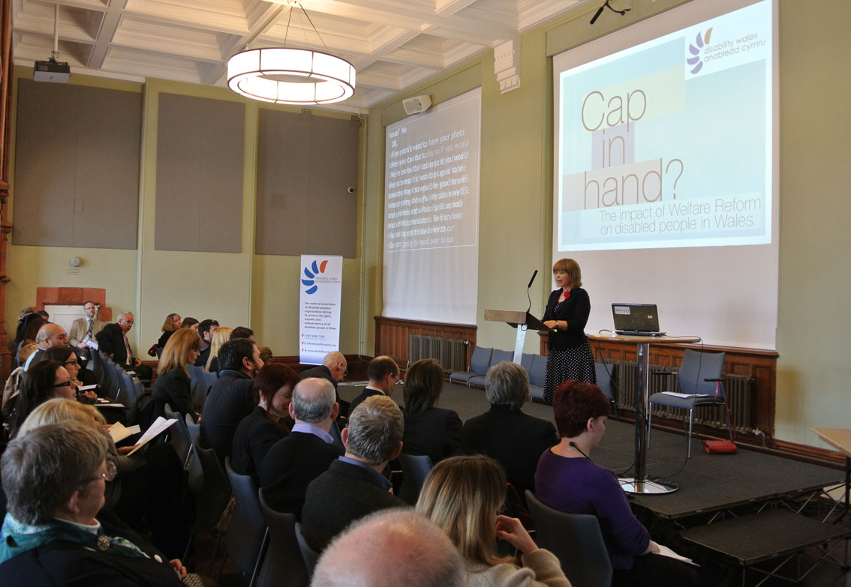

DW published a major report Cap in Hand: the impact of Welfare Reform on Disabled People in Wales, produced on our behalf by the Bevan Foundation at a high profile event in the Pierhead, Cardiff Bay. Attended by more than 40 participants it was sponsored by Leanne Wood AM, Leader of Plaid Cymru. Guest speakers included Victoria Winkler, Director of the Bevan Foundation, Amelia John, Head of Fairer Futures at Welsh Government, and Owen Smith MP, Shadow Secretary of State for Wales. Media coverage included items on ITV Wales Six O’clock News and Radio Cymru.

Cap in Hand outlines benefit by benefit the changes being introduced under welfare reform and their likely impact. It is illustrated with case studies provided by members on the effects they are already experiencing or fear in the future.

The report has been widely praised for providing a timely and useful resource in helping people to understand and prepare for the changes and also as a lobbying tool:

“I really enjoyed the [Cap in Hand] report launch earlier this week. I’ve had a few conversations with health colleagues about the findings and they all want to take a copy away with them!”
Paula Walters, NHS Centre for Equality and Human Rights

“We attended the Launch event yesterday on the excellent report 'Cap in Hand' that Disability Wales commissioned. It will provide us all with some concrete ammunition to continue to lobby Westminster.”
Kate Young, All Wales Forum for Parents and Carers

New Benefits Leaflets

As well as the Cap in Hand Report, DW also launched the first of three leaflets about specific benefit changes: Personal Independence Payment; Housing Benefit; and Employment and Support Allowance. Undertaken in partnership with the Community Housing Cymru campaign Your benefits are Changing, the leaflets feature DW members and include their ‘top tips’ for preparing for the changes. The colourful and easy to read leaflets have proved very popular and have been ordered in bulk by Housing Associations amongst others.

Representing Disabled People in Wales

As the national umbrella body, DW represents both members and wider disability interests in Wales on some UK Task Groups related to Welfare Reform. These include the DWP PIP Implementation Advisory Group and the Capita PIP Expert Collaboration Forum. Its membership of these should not imply support either for the abolition of DLA or the introduction of PIP. However they do provide a forum to ensure that the concerns of disabled people in Wales are heard and the opportunity to ensure that the application and assessment process is as accessible and humane as possible and moreover learn the lessons from the deeply flawed Work Capability Assessments.

DW was pleased to secure an additional Wales representative on the DWP Advisory Group, taken up by Jim Crowe from Learning Disability Wales. It also argued successfully for the Capita Group to meet in Cardiff and hold a round-table event with other national disability organisations in Wales.
As well as PIP, DW has been closely involved in consultations regarding the closure of the Independent Living Fund in 2015 and transitional arrangements when the funding is transferred initially to Welsh Government. DW ensured that a consultation event was held in Wales, in Newtown and that a representative group of ILF recipients and parents were invited.

DW was subsequently invited by Welsh Government to participate in an advisory group to identify options for the future of ILF funding in Wales for consideration by the Deputy Minister of Social Services, Gwenda Thomas AM.

Framework for Action on Independent Living

Impact

“In the JCHR’s Report, we commended the Welsh Government’s decision to produce its framework for independent living, having previously heard evidence from witnesses such as Rhian Davies of Disability Wales that Wales did not at the time have such a framework or strategy.”
Dr Hywel Francis MP

DW’s lobbying for disabled people’s right to live independently in the community culminated in the Ministerial launch of the draft Framework for Action on Independent Living to a packed audience at DEWIS Centre for Independent Living in Trefforest.

As well as the Minister Jane Hutt, guest speakers included Dr Hywel Francis MP, Chairperson of the Joint Committee on Human Rights (JCHR), Steve Harris, Chief Executive of DEWIS, DW’s Chief Executive Rhian Davies and Sara Head, Bronze Medallist at the London 2012 Paralympics. All six priorities identified by members in DW’s 2011 Manifesto for Independent Living which called on Welsh Government to introduce a strategy were included and expanded upon in the draft Framework.

DW worked co-productively with WG officials in arranging and facilitating the National Steering Group, five working groups and seven regional briefing events. Many of DW’s members participated in these groups which informed the drafting of the Framework. Of particular note is the emphasis given to the crucial role of Disabled People’s Organisations in working locally with public bodies to implement the Framework and for them to have the necessary support to do so.

During the consultation period, DW continued to work with officials in facilitating 5 meetings around Wales, including an event aimed specifically at Disabled People’s Organisations. On behalf of Wales Disability Reference Group, DW also coordinated three sessions of evidence to Cross Party Disability Group which informed its own response.

Disability Hate Crime

Impact

“The work that you did on disability hate crime was first class.”
Lindsay Whittle AM, speaking at the Communities, Equality and Local Government Committee, June 2013

DW continues to play a leadership role in the Disability Hate Crime Action Group Cymru and represents it on the WG Task Group established to develop a Framework for Action on Hate Crime. DW is also a member of the National Steering Group convened by the Association of Chief Police Officers (ACPO) Wales Diversity Group to pilot a new approach to tackling disability hate crime, used successfully in cases of domestic abuse: Multi Agency Risk Assessment Conference (MARAC). Both of these initiatives were developed in response to the EHRC’s Inquiry into Disability Related Harassment and the recommendations contained in the report: Hidden in Plain Sight (2011).

The report also highlighted the need for raising awareness of disability hate crime in schools, particularly as many disabled people who gave evidence to the Inquiry referred to avoiding certain ‘hot spots’ which include school gates and bus stops at home time. Drawing on these findings, DW successfully applied for Home Office Community Action Against Crime Innovation Funding to run a Forum Theatre project to tour schools and youth centres in Bridgend County Borough Council.

Forum theatre is a form of theatre that enables the audience to intervene at key stages and shape what happens. It provides a safe way for people to try and find effective solutions and understand the implication of their actions.

In partnership with Taking Flight Theatre Company and in consultation with disabled people living in Bridgend a piece of Forum Theatre was devised entitled Real Human Being. Four young disabled and non disabled actors were cast in the show: Cara Readle, Dan Edge, Amy Griggs and Simon Morgan Thomas.

The Home Office Funding enabled Real Human Being to be toured to 5 Schools and 3 Youth Centres in Bridgend aimed at young people aged 12-14. However additional funding from Welsh Government supported an extended tour to a further 21 schools and youth centres in Cardiff, the Vale of Glamorgan, Swansea, Carmarthenshire, Pembrokeshire and Flintshire:

“When I went to see a performance of Real Human Being in Bridgend I saw the impact it had on the young people watching and how effective it was at teaching them about hate crime.”
Jane Hutt AM, Minister for Finance and Leader of the House

In total Real Human Being was performed in 40 schools including youth centres and seen by 2920 pupils and teachers. The evaluation undertaken by Community Development Foundation outlined the difference it made in the following areas:

• Engaging young people with the topic of disability hate crime
• Improving disability hate crime reporting
• Increasing understanding of disability
• Changing attitude and behaviour

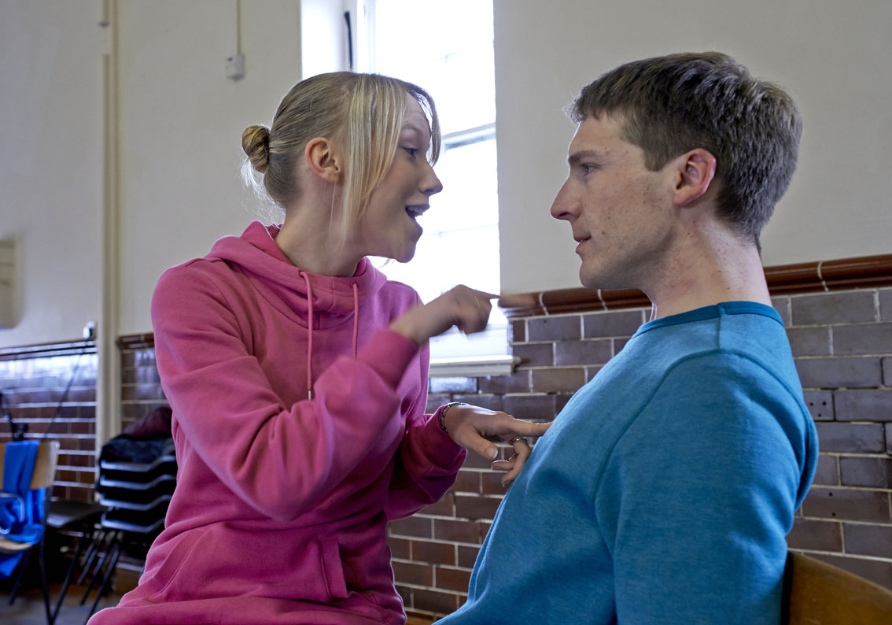

Head of PSE and Careers at Bryntirion Comprehensive School, Tamse Preece, stated:
“In my experience, there is no medium to rival live theatre to truly bring home the gravity of these issues. This also is the feedback from our students who tell me that they cried, felt physically sick and deeply empathised with all of the characters as a result of their ability to personally engage with the characters and actors.”

Year 9 pupils from Stanwell School, Penarth wrote to the cast after the performance, giving their response to Real Human Being:

“We now understand what’s it’s like to have a disability and how hurtful it is when people insult them. We also now know what many of these abusive words mean and we will now never use them.”

An important element in the success of the project was working in partnership with other agencies including: Bridgend Community Safety Partnership, Bridgend anti-bullying initiative, South Wales Police, Bridgend College, the All Wales Schools Liaison Core Programme and Welsh Government. The support of these partners as well as their enthusiasm was invaluable:

“It was a brilliant project, from the first time I heard about it I knew I’d try and help in any way I could.”
Bridgend Hate Crime Officer

Objective 4:

To develop sustainable funding arrangements

As with most organisations that receive public funding, DW has seen a reduction in grant income. It fully embraces the need to diversify its funding base so that it is less reliant on government grants and particularly through generating income such as delivery of training and consultancy services where subject to DW’s charitable objectives there is no restriction on how the fees earned are spent.

The Board commissioned a feasibility study into the potential of a training and consultancy service and has followed up on some of the recommendations. This included developing a network of trainers and consultants which some members have joined. DW also created the post of Business Development Manager to progress income generation activity following a vacancy arising in the organisation.

The Funding Committee which includes Directors and Staff oversaw the submission of four funding bids of which three were successful: BIG Lottery Community Voice Programme in Bridgend and Pembrokeshire; Welsh Government Equality, Inclusion and Diversity Division for the Extension Tour of Real Human Being; and Communities 2.0 for the Digital Lives Project.

DW also secured a contract with DWP Office for Disability Issues to produce a report on Social Media and Disabled People. It undertook this work jointly with the company Social Spider.

Other contract work included collaboration with Shelter Cymru on Welsh Government commissioned research into accessible housing registers. On the training front DW secured a twelve month contract to deliver Disability Equality Training at Parc Prison in Bridgend. Other sessions were delivered for Cardiff Metropolitan University and Coleg Gwent.

Objective 5:

To maintain effective and sustainable governance and management arrangements

“DW have robust systems in place which demonstrate how they are using the IIP Framework to achieve their business aims and objectives. They are a passionate, committed, high profile organisation who achieve a great deal with an amazingly small team.”
June Williams, IIP Assessor, December 2012

Governance and financial arrangements were under scrutiny at all publicly funded charitable organisations in Wales following some high profile scandals in the sector. On behalf of members, DW places great emphasis in ensuring that it operates with due probity and in recent years has undertaken full scale reviews of its policies and procedures to ensure that these are fit for purpose. This was acknowledged in response to due diligence exercises undertaken by Welsh Government and the Charity Commission into organisations receiving government funding.

External validation of DW’s commitment to good practice also came through retaining Investors in People (IIP) status for a further three years following a formal review and in achieving Level 3 of the Green Dragon Environmental Standard.

The IIP Assessor identified several areas of good practice including DW’s Business Planning process, development of Environmental policies and commitment to equality.

In line with the Green Dragon Standard, Disability Wales improved on its target for the overall reduction in the organisation’s Carbon Dioxide emissions and also the usage of Water which was achieved through increased use of telephone conferences, public transport and installation of devices to control water flow.

40th Anniversary

Impact

“I just wanted to congratulate Disability Wales on their 40th Anniversary. I have just watched Story at 40, I really enjoyed the stories and truly believe that everyone has a story to tell!”
Sherrall Morris, DW Member

2012 was a year of celebration for DW given its 40th Anniversary and members were engaged in several events to mark the occasion: the All Aboard Transport Challenge; the oral history film project Story at Forty: the lives and times of disabled people in Wales; and the Back to the 70s Anniversary Dinner and Disco

All Aboard Transport Challenge

“We were very pleased to be invited to be part of the celebrations. We enjoyed taking part in the Travel Challenge and being able to tell others at the AGM about the things that we do and how we work as a forum.”
Pembrokeshire Young Voices for Choices

Four young disabled people and two support workers from member group Pembrokeshire Young Voices for Choices set off from Haverfordwest and travelled 827 miles around Wales by public transport.

All Aboard highlighted a major barrier to independent living – access to public transport. In fact participants reported increased confidence in using public transport as a result of their generally positive experiences. As this activity involved a journey across Wales, it also emphasised DW’s role as a national organisation with many members following it on Facebook and Twitter.

The Challenge was undertaken in partnership with Arriva Trains Wales, and findings were included in WG’s Draft Framework for Action on Independent Living and have informed ongoing discussions on various transport advisory bodies with which DW is involved. It will have a legacy beyond the event itself and the media attention it generated at the time.

Back to the 70s Dinner and Disco

“I enjoyed the evening very much and I was able to wear some original 70s gear from my attic.”
DW Member

Held at the Ramada Plaza in Wrexham on the eve of DW’s National Seminar and AGM, Directors, staff and members donned 70s costume, sipped Babycham, enjoyed Steak Diane and Black Forest Gateaux and boogied to the top sounds from the decade.

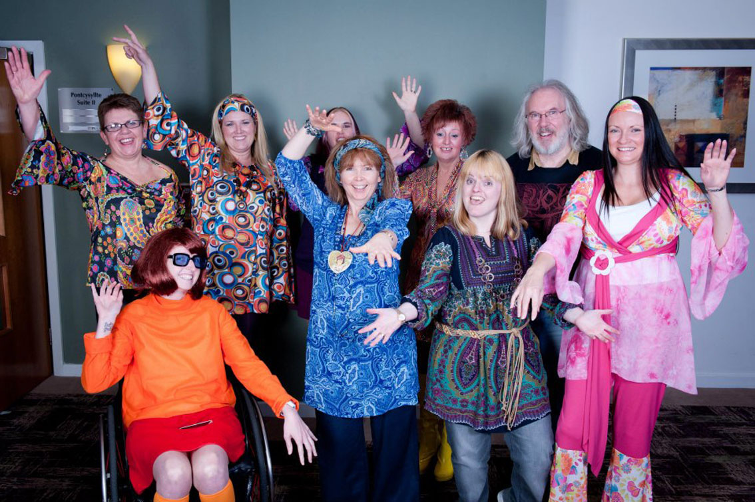

Story at Forty

“I am more than pleased that Disability Wales included me amongst the Production Team as this led to my making many more Friends, and to my being encouraged to....pass the information and knowledge gained onto others....”
Story at 40 participant

Story at 40: the lives and times of disabled people in Wales was financially supported via a grant from the Heritage Lottery Fund. It is an oral history film project with tells the stories in their own words of the six interviewees all of whom celebrated their 40th Birthday during 2012. The project also recruited seven disabled volunteers of all ages who were trained up as members of the production crew working with professional film company Practice Solutions.

The training included sessions in Disabled People’s History delivered by Professor Colin Barnes, Oral History led by Dr Beth Thomas from the Oral History Society and film production by Practice Solutions. Participants reported on how the training broadened their knowledge and increased confidence and skills in using digital media with several participants making their own short films which they have uploaded to the Internet.

April, Carrie-Anne, David, Ian, Lynzi and Sarah are the subjects of the films. They come from across Wales and include people born with impairments as well as those who became disabled in young adulthood. They speak honestly and openly about their experiences including school days, work, family life as well as their hopes for the future.

Story at Forty was launched on the International Day of Disabled People at the Pierhead, and sponsored by Mark Drakeford AM. Guest speakers included Jane Hutt AM, Minister for Finance and Leader of the House, Carys Howell from the Heritage Lottery Fund and project participants.

The films are available on DW’s You Tube Channel and a resource pack has been produced on our behalf by Chris Tally Evans to be used when screened at public events. The unedited footage will be held by the National Sound and Screen Archive as resource for future researchers.

As well as providing a platform for disabled people today, a vital element of Story at 40 is that it will have a lasting legacy. Mike Mantin from Swansea University offered this assessment of the project in his Disability and Industrial Society blog:

“The project represents a vital step in oral disability history, each interview offering a glimpse into the experiences of people who rarely have their everyday lives and opinions broadcast.......Story at 40 allows its participants to discuss what being disabled means for themselves and their identity. Whether it concerns activism, sign language, labelling or coming to terms with a condition, all have something to say. Disabled people are difficult to locate in history. Often they appear to be invisible in historical sources, and what isn’t said in the records becomes as significant as what is. Oral history can be one of a number of different ways to ensure that the recent history of disabled people does not go undocumented.”

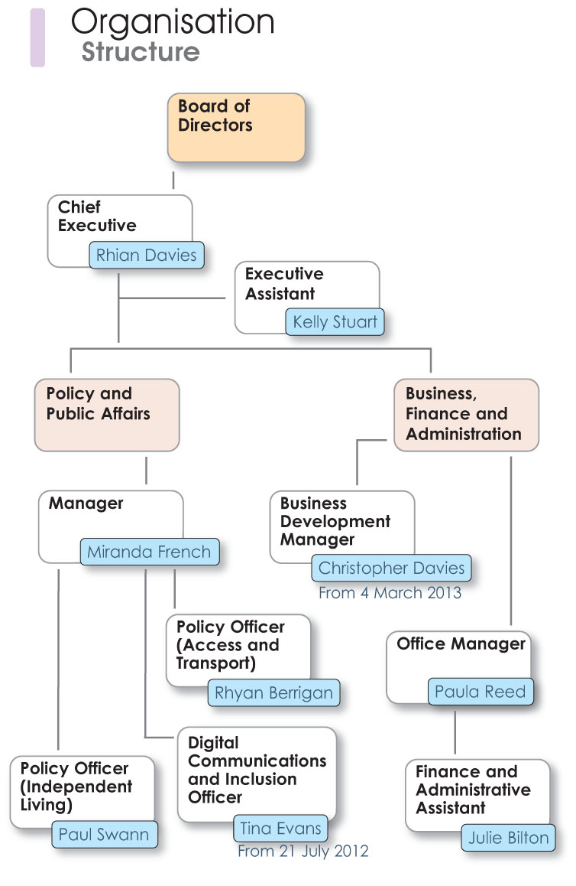

Membership of DW 2012/2013

Acquisitions Cardiff University
Action of Hearing Loss
Age Concern Cymru
Aneurin Bevan Community Health Board
Antur Teifi
Arfon Access Group
Arthritis Care In Wales
ASBAH Cymru
Breakthrough UK Limited
Breakthrough UK Limited
Brecon and District Disabled Club
Bridgend Coalition of Disabled People
British Limbless Ex-Service Mens Association
C.L.I.P
C.V.S.C
Cadwyn Housing Association
Caerphilly County Borough Access Group
Cardiff & The Vale Parents Federation
Cardiff Access Group
Cardiff Community Housing
Cardiff People First
Cardiff Third Sector Council
Cardiff Vale and Valley
Cardiff YMCA Housing Association
Care and Repair Cymru
Carmarthenshire Disability Coalition for Action
Carmarthenshire Disabled Access Group
Cartrefi Cwymunedol Gwynedd
Catch Up Ltd
Centre For Independent Living De Gwynedd
Ceredigion County Council Social Services
Children In Wales
City and County of Swansea
Clwyd Alyn Housing Association
Conwy County Voluntary Access Group
Cwmbran Community Council
DAGTHA
Dewis Centre for Independent Living
Dial UK (Incorporating Scope)
Disability Action Group Wales
Disability Arts Cymru
Disability Law Service
Disability Network Action Group
Disability Resource Centre
Disability Sport Wales
Dyfed Powys Police - Citizen Focus Policing Services
Equality and Human Rights Commission
Fieldsman Trails - Access Consultancy
First Choice Housing Association Ltd
Flintshire Disability Forum
Flintshire New Age Kurlers
Friends of the Young Disabled
GAVO
Glynneath Community Council
Groundwork Wales
Grwp Mynediad Meirionnydd Access Group
Guide Dogs for Blind
Gwendraeth Valley Community Enterprise (Job Force Wales)
Gwent Disabled Motorists Club
Gwent Hospitals Contributory Fund
Gwent Police Cohesion Team
Headway Cardiff
Headway Swansea
Health Promotion Library
HMP & YOI Parc (G4S Care and Justice Services)
Learning Disability Wales
M S Society Wales
Machynlleth Town Council
Mantell Gwynedd
Mencap Cymru
Merthyr Tydfil Institute for the Blind
Merthyr Valley Homes
Monmouthshire County Council
Nantglo and BlainaTown Council
Narberth Town Council
National Commission Person with Disability
Neath Port Talbot CBC
Neath Port Talbot CVS
Newport Access Group
Newport City Homes
NHS Centre for Equality and Human Rights
P.I.P.P.A
Pembrokeshire Access Group
Penarth Town Council
Rhondda Cynon Taff Access Group
Rhondda Cynon Taff Council
Rhondda Cynon Taff People First
RNIB Cymru
S4C
Safer Wales
SAIL
Sefydliat St. Loyes Foundation
Sense Cymru
Services for Independent Living (s4il)
Shaw Trust
South Wales Disability Open Network (SWDON)
South Wales Police
Stroke Association
Swansea Care and Repair
Swansea Disability Initiative
Taffs Well Community Council
Tai Pawb
TARAN Disability Forum Ltd
The Keith Morris Memorial Fund
Torfaen County Borough Council
UNISON Cymru/Wales
Unite The Union
University of Glamorgan
University of Wales Newport
Vale Centre for Voluntary Services
Viva! (Wales)
Wales Council for Deaf People
Wales Council for the Blind
Wales Mobility and Driving Assessment Services
Ynys Mon (Isle of Anglesey) Access Group
Young Voices for Choices

